Mission Peak Optics Inc.
Microspot Thin Film Measurement System MP100-FPD
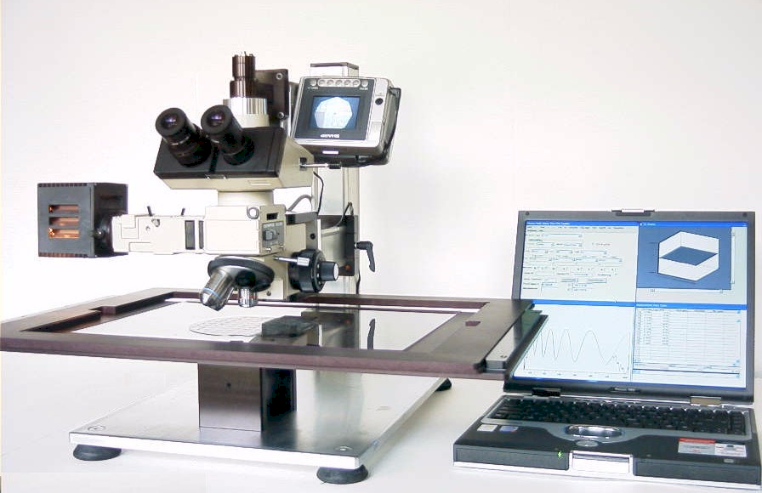
Easy to use + Low Cost + Compact Size + Flexibility = High Performance
The MP100-FPD Thin Film Measurement System comes standard with an extra large 470 X 370 mm X-Y Stage, which is designed to generate a 3D Graph to show the Thickness distribution. With Two Points De-Skew function it can locate the measurement spot quickly. The MP100-FPD provides state-of-the-art function to measure filled cell gap on LCD, polyemide on ITO, color filter CIE chromaticity, and color filter thickness. MP100-FPD is also able to measure Oxide, Nitride, Photoresist and Polysilicon films. The powerful software algorithms can perform single, double, and triple layer thickness calculations. As well as special search and fit routines that quickly converge the algorithm and variables into an accurate thickness measurement tool.

The MP100-FPD uses multiple gratings to achieve a wide spectrum range from UV to NIR. The unique video display design provides the operator with an ergonomic view of the sample area thus eliminating tedious viewing through conventional microscope optics. A USB interface connects directly to a laptop computer to make the system compact and portable if necessary.

The MP100-FPD user interface is divided into four quadrants that represent measurement setup parameters, visual spectral display, thickness result bar graph and a thickness result data table. This fully illustrated interface provides instant data return. The main MP software operates in conjunction with Microsoft Office™, which allows the operator to save measurement data in MS EXCEL™ format and store it within a MS ACCESS™ database for future reference. This collaboration of software allows you to generate the reports that you need quickly and easily.

MP100-FPD Microspot Thin Film Measurement System

Spectrometer

TV camera with View screen
Spectrometer
Spectrometer
Slit
Aperture
Light Source
Objective Lens
Sample

Spectrometer
Fiber Optics

MP100-FPD Architecture

Specifications (MP100-FPD):

Scanning range: 380 nm to 950 nm, standard
Spectrum resolution: 2 nm
Precision: 0.2 nm
Measuring speed: 2 seconds

Measurement specification:

 |  | 1st Layer |  | 2nd Layer |  | 3rd Layer  0 -10,000Å |  | 4th Layer  0 -10,000Å
Film Type | Objective  Lens | Range | 1σ | Range | 1σ | Range | 1σ | Range | 1σ
P1/P2/ITO/Oxide/Gla | 5x, 10x | 100 - 30,000Å | 5Å | 100 - 10,000Å | 5Å | 100 - 2,000Å | 5Å | 100 - 3,000Å | 5Å
Oxide/Si | 5x, 10x | 200 - 30,000Å | 2Å
 |  | 30,000,- 50,000Å | 5Å
 | 50x | 200 - 10,000Å | 2Å
 |  | 10,000 - 20,000Å | 5Å
Nitride/Si | 5x, 10x | 150 - 20,000Å | 2Å
 | 50x | 150 - 15,000Å | 2Å
Photoresist/Si | 5x, 10x, 50x | 500 - 20,000Å | 5Å
Nitride/Oxide/Si | 5x, 10x | 150 - 20,000Å | 5Å | 100 - 10,000Å | 5Å
Poly/Oxide/Si | 5x, 10x | 100 - 5,000Å | 5Å | 100 - 10,000Å | 5Å
Oxide/Poly/Oxide/Si | 5x, 10x | 100 - 10,000Å | 5Å | 0 - 10,000Å | 5Å | 0 - 10,000Å | 5Å
Oxide/Al | 5x, 10x, 50x | 2,000 - 20,000Å | 5Å
Photoresist/Cr | 5x, 10x, 50x | 500 - 20,000Å | 5Å
Oxide/NiFe | 5x, 10x, 50x | 2,000 - 20,000Å | 5Å
Photoresist/Glass | 5x, 10x, 50x | 500 - 20,000Å | 10Å
ITO/Oxide/Glass | 5x, 10x, 50x | 100 - 3,000Å | 2Å | 100 - 2,000Å | 2Å
Very Thick Film | 5x | 50,000 - 150,000Å | 100Å
Customized film types are available for your applications.

Measuring spot size: 5x Objective is 50 microns, 10x Objective is 25 microns, 50x Objective is 5 microns
Viewing options: 2" camcorder screen, and dual microscope eyepiece lenses.

Mission Peak Optics Inc.
46941 Rancho Higuera Road, Fremont, CA 94539 USA
Tel: (510) 438-0384 Fax: (510) 438-9795
Website: www.missionpeakoptics.com Email: sales@missionpeakoptics.com

